Department Request Form for Event Space
At The 3rd Floor Worcester DC
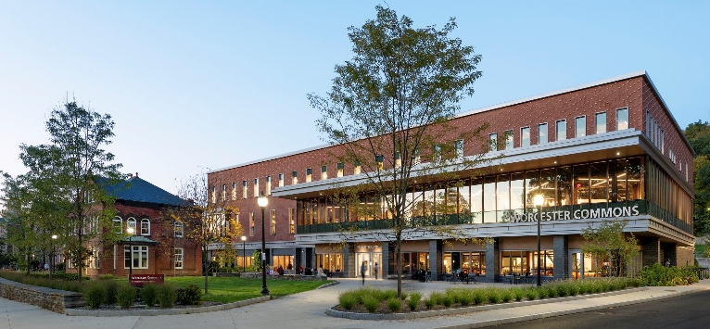
Worcester Dining Commons Meeting Rooms - Permanent set rooms (room set up cannot be altered)
Once you have completed the form please email to The Event Sales office at CCEVENTS@UMASS.EDU
There is no Food or Beverages allowed in these spaces
325 | Conference Set for 8
333 | Hollow Box for 20
335 | Double Horseshoe for 20
339 | Hollow Box for 20
341 | Double Horseshoe for 20
343 | Hollow Box for 20
345 | Conference for 12 and (2) 4 person double blocks
347 | Conference for 8
349 | Conference for 8
351 | Conference for 8

Name of Event:
Contact Person:
Sponsoring Department/Organization:
Speed Type:
Date of the event: (if you need multiple dates for same event please list them all on one form)
Number of attendees:
Time of the event:
Requested Location:
A/V: In these rooms there is a screen or monitor you would hook your Laptop directly into (cords are provided) There is no AV assistance available in these rooms.

