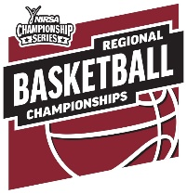
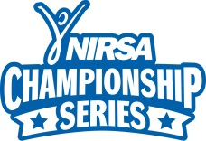
2020 NIRSA Regional Basketball

University of Massachusetts - Amherst
March 13-15, 2020
Tournament Registration Form

Institution: Division (circle one): Men’s Women’s Co-Rec Unified
Team Name: Email Address:
Team Rep: Phone:
Address: City: State: _____ Zip:

NIRSA recognizes and celebrates the transgender student population among its tournament players and encourages students to participate in intramural sports and sport club divisions based on their expressed gender identity.

All participants must comply with the NIRSA Championship Series eligibility guidelines. Players with questions about their eligibility or who have need for additional support are encouraged to contact the NIRSA Director of National Sport Programs Valerie McCutchan.

Incomplete forms or entries submitted without an entry form, entry fee, or Campus Recreation representative signature will NOT be accepted. An original player certification form with your institutions Registrar’s seal must be received by the entry deadline of Monday, March 9th

Please list players in ascending order by jersey number; Roster limit – 15 for Men’s and Women’s teams
Player | Jersey # | Participant Name | Former Collegiate Varsity Player | # of years on a NIRSA roster | # of years on a varsity roster/squad list: | Email Address
1 |  |  | YES / NO
2 |  |  | YES / NO
3 |  |  | YES / NO
4 |  |  | YES / NO
5 |  |  | YES / NO
6 |  |  | YES / NO
7 |  |  | YES / NO
8 |  |  | YES / NO
9 |  |  | YES / NO
10 |  |  | YES / NO
11 |  |  | YES / NO
12 |  |  | YES / NO
13 |  |  | YES / NO
14 |  |  | YES / NO
15 |  |  | YES / NO

Coaches:

Entry Fee*: $300 if received by February 26th 2020. $350 if received after February 26th, 2020.

Payment Options: 1) Check (Payable to UMass Students of Recreation) or
2) Pay online using a credit card. The link will be e-mailed once the Registration form is received

Entry Deadline: Tuesday, March 3 Received by: Entry Status Notification:

Send Completed Forms to: ndamato@umass.edu

