Abstract: We examine the generalization of a fully-distributed method for computing spectral clusters to the case of aperiodic strongly-connected digraphs. In doing this we show that the sign of eigenvector components can be obtained via the Fourier series of a local wave-equation relaxation. Further we provide a runtime complexity for this variety of digraphs differing from the undirected case.

Introduction:
- Spectral Clustering: A bulk of work has been done in examining the problem of how to best determine clusters based on a similarity graph. There are many ways of doing this with varying runtimes and degrees of accuracy. One of the best documented of these is the method of spectral clustering [1]. The method relies on the well-known Cheeger’s inequality to approximate the cut of least conductance from the first eigenvector of the graph Laplacian. In the undirected case we say that a connected graph $G=(E,V)$ has the graph Laplacian $L\left(G\right)=D\left(G\right)-A(G)$ where $D(G)$ is the diagonal-degree matrix of the graph and $A(G)$ is the adjacency matrix of $G$. $L\left(G\right)$ has several nice properties, among them are the fact that all eigenvalues are greater than or equal to zero, and most importantly the first non trivial eigenvalue obeys Cheeger’s inequality,
$$\frac{{h_{g}}^{2}}{2}≤λ_{2}≤2h_{g}$$

where $h_{g}$ is Cheeger’s constant and can be intuitively understood as the minimal-conductance cut on the graph defined as…
$$h_{g}\min_{S}\left\{\frac{\left|δS\right|}{\left|S\right|} :S ⊆V, 0<\left|S\right|<\frac{\left|V\right|}{2} \right\}$$
This allows for us to cluster based on the entries of the eigenvector associated to this eigenvalue $λ_{2}$. In most literature and in application this is done via the k-means algorithm and has a runtime of $O(n3).$

- Wave Equation Clustering: In 2011 a paper was published outlining a fully distributed method for computing spectral clusters [2]. We outline the algorithm here and provide some important facts from the paper.

The main concept of the algorithm is to treat the graph as a drum-of-sorts and to locally relax the wave equation at each node. Then the first peak of the Fourier transform at each node assigns it to a cluster based on the sign of the associated Fourier coefficient. We define the discretized wave equation as follows,
$$u_{i}\left(t\right)=2u_{i}\left(t-1\right)-u_{i}\left(t-2\right)-c^{2}\sum_{j∈N(i)}{{L\left(G\right)}_{i,j}u_{j}(t-1)}$$
where $u_{i}(t)$ denotes the value of node$i$ at time $t$, $c^{2}$ is the transmission speed of the wave equation, $N\left(i\right)= \left\{j∈G:j\sim i\right\}$. It turns out that to ensure stability one can show through some algebra that one requires,$$0 <c<\frac{2}{\sqrt{p(L)}}$$
where $p(L)$ is the spectral radius of $L(G)$. Recall that to assign two clusters we need to
resolve the first peak in the Fourier series. Therefore, for some number of cycles $η$ and
frequency $ω_{1}$ we know that $T_{max}=\frac{η}{ω_{1}}$ will be sufficient for obtaining a binary cluster.
through some simple algebra from here it can be shown that,
$$T_{max}=O\left({arccos\left(\frac{2+c^{2}λ_{2}}{2}\right)}^{-1}\right)$$
- Example:
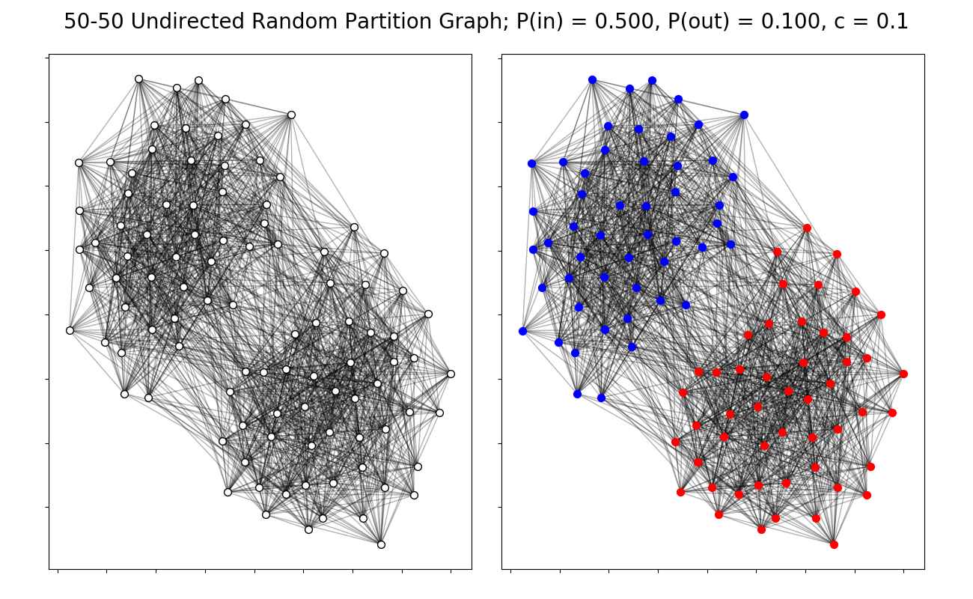
Above is an example of a given cluster from the distributed algorithm on a 100 node
undirected partition graph with inter-cluster connection probability 0.1 and intra-cluster
connection probability 0.5.

Extension:
- The Directed Graph Laplacian: We are trying to extend this wave equation clustering method to the realm of directed graphs so we clearly require a new notion of the graph Laplacian $L(G)$. Luckily, assuming our graph is strongly-connected and aperiodic Chung has written about an alternative Laplacian we will call $L_{D}$ that is defined as follows [3],
$$L_{D}=I-\frac{ϕ^{\frac{1}{2}}Pϕ^{-\frac{1}{2}}+ ϕ^{-\frac{1}{2}}P^{T}ϕ^{\frac{1}{2}}}{2}$$
where $ϕ$ is the stationary matrix of the transition matrix $P$ on the graph. This matrix is
Hermitian and as such all eigenvalues again are greater than or equal to zero, but most
Importantly the first non-trivial eigenvalue of $L_{D}$ again obeys Cheeger’s inequality and as
Such can be used for spectral clustering.

- Theory: We now have to ensure stability of our relaxation. This entails bounding the spectral radius of our Laplacian LD. This is known to be bounded above by 2 [4]. However, the derivation is difficult to find in literature so we outline it here,
  - Proof: First we consider the vector $ϕ^{\frac{1}{2}}I$ understood as the square root of the stationary matrix applied to the vector of all 1’s. Call $P=ϕ^{\frac{1}{2}}Pϕ^{-\frac{1}{2}}$ then,
$${Pϕ}^{\frac{1}{2}}I=ϕ^{\frac{1}{2}}PI=ϕ^{\frac{1}{2}}I$$
$$I^{*}ϕ^{\frac{1}{2}}P=I^{*}ϕϕ^{\frac{1}{2}}={I^{*}ϕ}^{\frac{1}{2}}$$
Showing that $ϕ^{\frac{1}{2}}I$ is both a left and right eigenvector of $P$ with eigenvalue 1.
Those familiar with the Perron-Frobenius theorem [5] will notice that this implies the spectral radius of $P$, $p(P)=1$ . It turns out that the same property
holds for $P^{*}$.

Now we assume $\left\|P\right\|>1$ and call $ϕ^{\frac{1}{2}}I= θ$. Then,
$$θ^{*}P=θ^{*} ⟹ θ_{j}=p_{0j}θ_{0}+…+p_{nj}θ_{n}= \sum_{k}{p_{kj}θ_{k}}$$
$$Pθ=θ ⟹ θ_{i}=p_{i0}θ_{0}+…+p_{in}θ_{n}= \sum_{k}{p_{ik}θ_{k}}$$
${\left\|P\right\|}_{2}>1⇒∃a_{ij}>1$. Therefore, we write,
$$θ_{i}=a_{ij}θ_{j}+A$$
$$θ_{j}=a_{ji}θ_{i}+A$$
$$θ_{i}={a_{ij}}^{2}θ_{i}+(Aa_{ij}+B)$$

We know $A,B>0$ and $a_{ij}>1$, so we have reached a contradiction and know ${\left\|P\right\|}_{2}=1$. From here we simply need a straightforward application of the triangle
Inequality,
$$p\left(L_{D}\right)≤p\left(I\right)+p\left(\frac{P+ P^{*}}{2}\right)$$
$$⇒p\left(L_{D}\right)≤p\left(I\right)+\frac{1}{2}p\left({\left\|P+ P^{*}\right\|}_{2}\right)$$
$$⇒p\left(L_{D}\right)≤p\left(I\right)+\frac{1}{2}p\left({\left\|P\right\|}_{2}+{\left\|P^{*}\right\|}_{2}\right)$$
$$⇒p\left(L_{D}\right)≤2$$
Therefore, the same bounds on $c$ as in the undirected case maintain stability of
our relaxation.
- Runtime Complexity: We now analyze the runtime complexity of the algorithm on our class of directed graphs. Recall our runtime complexity in the undirected case,
$$T_{max}=Oarccos\left({⁡\left(\frac{2+c^{2}λ_{2}}{2}\right)}^{-1}\right)$$
Where $λ_{2}$ is the first non-trivial eigenvalue of L(G). Recalling the analysis from earlier this comes from some algebra based on the term $T_{max}=\frac{η}{ω_{1}}$. This same analysis works in the directed case, so we acquire the same time complexity.

Luckily, we can classify a “worst case scenario” for our runtime based on a lower bound for $λ_{2}$ provided by Sinan Aksoy’s thesis [6].
$$λ_{2}≥\frac{\min_{u}{(ϕ\left(u\right))}}{2D\max_{u}{(d^{+}\left(u\right))}}$$
where $D$ is the diameter of our digraph, and $d^{+}(u)$is the out-degree of node $u$. This gives us the following run time complexity,
$$O\left({arccos⁡\left(1- \frac{c^{2}\min_{u}\left(ϕ\left(u\right)\right)}{\underset{u}{4Dmax}\left(d^{+}\left(u\right)\right)}\right)}^{-1}\right)$$
- Cluster Example:
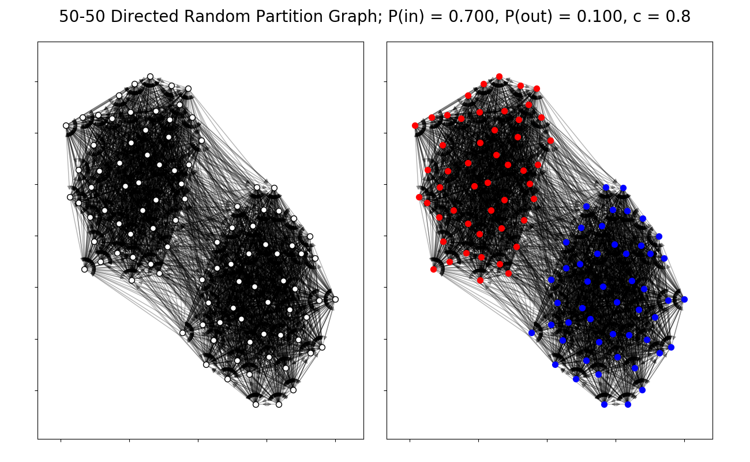
Above is an example of a given cluster from our extended algorithm on a 100-node directed partition graph with inter-cluster connection probability 0.1 and intra-cluster connection probability 0.7.
Conclusions: In this paper we have outlined an extension of the wave-equation based method for spectral clustering to the case of directed, aperiodic, strongly-connected graphs. We have illustrated why the stability analysis remains the same, and why we obtain the new runtime complexity of $O\left({arccos⁡\left(1- \frac{c^{2}\min_{u}\left(ϕ\left(u\right)\right)}{\underset{u}{4Dmax}\left(d^{+}\left(u\right)\right)}\right)}^{-1}\right)$.

Citations:
- Chung, “Spectral Graph Theory”, AMS, 1997
- Sahai, Speranzon, Banaszuk, “Hearing the Clusters in a Graph”, United Technology Research Center, 2011
- Chung, “Laplacians and the Cheeger inequality for directed graphs”, UCSD, 2004
- Chung, Kenter “Discrepancy inequalities for directed graphs”, Elsevier, 2014
- Chung, Lu, “Complex Graphs and Networks”, AMS, 2006
- Aksoy, Chung, “Random walks on directed graphs and orientations of graphs”, UCSD, 2017

