Diasporic Youth for Sexual Rights and Justice

A Viewing and Discussion Guide for Community Health Educators, Activists and Community Members

Written by the Hear Our Stories Project Team
2014

Contents

Introduction
- Project Overview and Intentions
- Project Timeline
- Digital Storytelling Overview
- Process

Story Viewing Guidelines
- Setting up a screening
- Technology
- Developing Group Guidelines
- Ensuring Emotional Support

Viewing Stories & Discussion Prompts
- Pre-screening discussion prompts
- Post-screening discussion prompts

Group Activities & Discussion Formats

Ethical Considerations
- Mandated Reporting
- Storyteller safety
- Trigger-warnings

Resources
- Articles & Suggested Reading List
- Project Partner Websites

Introduction

Project Overview and Intentions
Hear Our Stories: Diasporic Youth for Sexual Rights and Justice is a Ford Foundation-funded project, which uses new media (digital storytelling and body-mapping) to reveal how diasporic young mothers in Western Massachusetts experience and negotiate sexual health disparities. We prioritize uprooted young parenting women, whose material conditions and cultural worlds have placed them in tenuous positions, both socially constructed and experientially embodied. Existing programs and policies emphasize failure on the part of young parents, often promoting stigma through public messaging. The goal of this project is to flip that paradigm allowing young parents to be media-makers, crafting their own narrative bodies of work to shed light on their lived realities and act as a catalyst for micro and macro level policy change.

Hear Our Stories strives to showcase the knowledge, triumphs and challenges of young parents, creating space for their stories to be shared, networked and valued. Throughout the course of four four-day workshops in August – October of 2013, 31 digital stories were crafted by young mothers at The Community Adolescent Resource and Education (CARE) Center in Holyoke, Massachusetts. Each of these stories offers a unique perspective on structural violence, health disparities and self-preservation, through this subject-driven methodology.

The intention of the project is to provide a narrative jolt to the dominant discourse surrounding teen pregnancy and parenting in public health, policy and educational spheres, encouraging input and perspective from young parents themselves. Partners on the project include: The Center for Public Policy and Administration at the University of Massachusetts Amherst, The National Latina Institute for Reproductive Health, Civil Liberties and Public Policy, The Massachusetts Alliance on Teen Pregnancy, WGBY Springfield, The Center for Digital Storytelling and The Mauricio Gaston Institute for Latino Community Development and Public Policy.

An integral component of this project is integrating voices that are often silenced or given less prioritization that others. As a way of integrating new voices and challenging hierarchies in academic and political settings this project has peer mentoring aspects built into its foundation providing trainings and skill building opportunities for participants and researchers alike; something that the partner organizations have collaborated on extensively.

This project is steered by Women Organizing Across Ages (WOAA), a group of storytellers involved who are developing their capacity as sexual and reproductive rights advocates as they engage in project-sponsored trainings, workshops, meetings, and conferences, and has multi-level peer mentorship capacities.

Project Timeline

May 2013: All Project Partners participate in a digital storytelling workshop working from prompts connected to their lived experiences with reproductive health, justice and family making.

June 2013: The National Latina Institute runs a 3 day training at the Care Center in Holyoke: Latina’s Organizing for Leadership and Advocacy (LOLA).

August 2013: First two digital storytelling workshops are held at The Care Center in Holyoke

September: 2013: Workshop three is held at The Care Center in Holyoke. Monthly meetings for Women Organizing Across Ages (WOAA) begin.

October 2013: Final Workshop (4) is held at the Care Center in Holyoke. Stories are presented at the Center for Human Development Annual Conference in Springfield Massachusetts.

November 2013: Research Fellows attend New Leadership Networking Initiatives Annual Meeting in Austin Texas. Storytellers present at the Massachusetts Alliance on Teen Pregnancy Annual Conference in Boston, MA.

December 2013: Project staff members attend daylong policy training at the Center for Public Policy and Administration at University of Massachusetts, Amherst.

January 2014: Eight-week course at The Care Center with WOAA group members

February 2014: Eight-week course at The Care Center with WOAA group members

March 2014: Massachusetts Alliance on Teen Pregnancy leadership and advocacy training with WOAA group members at The Care Center.

April 2014: Storytellers present at the Civil Liberties and Public Policy Conference “From Abortion Rights to Social Justice: Building the Movement for Reproductive Freedom.” Massachusetts Alliance on Teen Pregnancy leadership and advocacy training with WOAA group members at The Care Center.

May 2014: A Community Forum and Public Screening are held in the City of Holyoke. Stories are presented at the Youth Empowerment and Adolescent Health (YEAH) Network, Annual Conference. A WOAA member partnered with the National Latina Institute for Reproductive Health to speak at a Congressional Hearing about young parents needs and rights.

June 2014: The project is presented and showcased the Youth Media and Sexuality Forum in Detroit.

July 2014: Ford Fellows summer internships at project partner sites (Center for Digital Storytelling, Massachusetts Alliance on Teen Pregnancy, National Latina Institute for Reproductive Health).

August 2014: Ford Fellows summer internships at project partner sites (Center for Digital Storytelling, Massachusetts Alliance on Teen Pregnancy, National Latina Institute for Reproductive Health). Research team meetings to brainstorm data codebook.

September 2014: Codebook construction completed. Research team begins to code data for analysis.

October 2014: Continued data coding.

November 2014: Continued data coding.

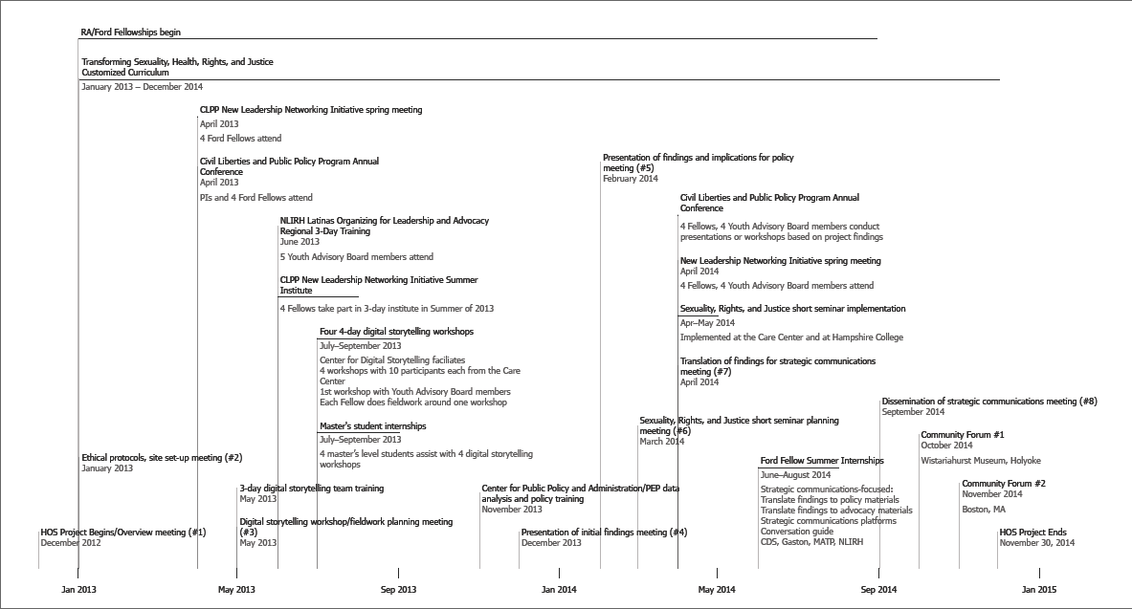

Digital Storytelling Overview
So often, the ways through which we understand and share our lived experiences is through storytelling. Sometimes we tell our own stories, and sometimes our stories are told for us. As is the case with all stories the storyteller shapes what is shared, emphasized and made visible or invisible through said action. Teen parents occupy a middle ground in society. They are hyper visible in their situation; young, pregnant and/or parenting, and frequently have their stories told for them. We see this on billboards, in edited clips from so-called reality television and in our own conversations. The intention of using digital storytelling with young mothers is to give them a moment to showcase their experiences and to be allowed the space to be the authorities on their histories, presents and futures. In this project salient topics that have been brought to light through digital storytelling include experiences involving; healthcare systems, support, violence, movement and mobility, education and surveillance.

Digital storytelling is a participant-driven way of media making. A storyteller creates a one-of-a-kind body of work documenting an aspect of there story and pulling it together through combining voice recordings, music as well as still and moving images. Generally speaking these works are between two and five minutes long and offer an autobiographical portrait of documentary work.

While there are many agencies that use digital storytelling and many formats that this medium can take, for the purpose of the Hear Our Stories project the methodology employed is the one crafted and facilitated by the Center for Digital Storytelling in Berkeley, CA.

The four workshops in which the materials for the HOS project were created took on the following format:

Day 1
- Storytellers gather together, participating in group building activities and discussing the seven elements of what makes a compelling digital story.
- Storytellers respond to writing prompts related to sexuality, parenting and access to services.
- Storytellers gather and hold a story circle, in which they share writing, experiences and offer each other feedback as to what makes sense to draft into a final script.

Day 2
- Storytellers draft their story scripts.
- Storytellers record their audio files, a voice over of them reading their story script.
- Storytellers storyboard their piece and create a shot list of videos and photos to make and find.
- Storytellers begin making images.

Day 3
- Storytellers continue making images and movies as well as scanning works (such as letters, artwork, family photos) to use in their stories.
- Storytellers are trained in using video editing software and begin pulling together their rough drafts.

Day 4
- Storytellers add effects and music to their stories.
- Storytellers finish their final drafts.
- Storytellers participate in a screening of their completed work.

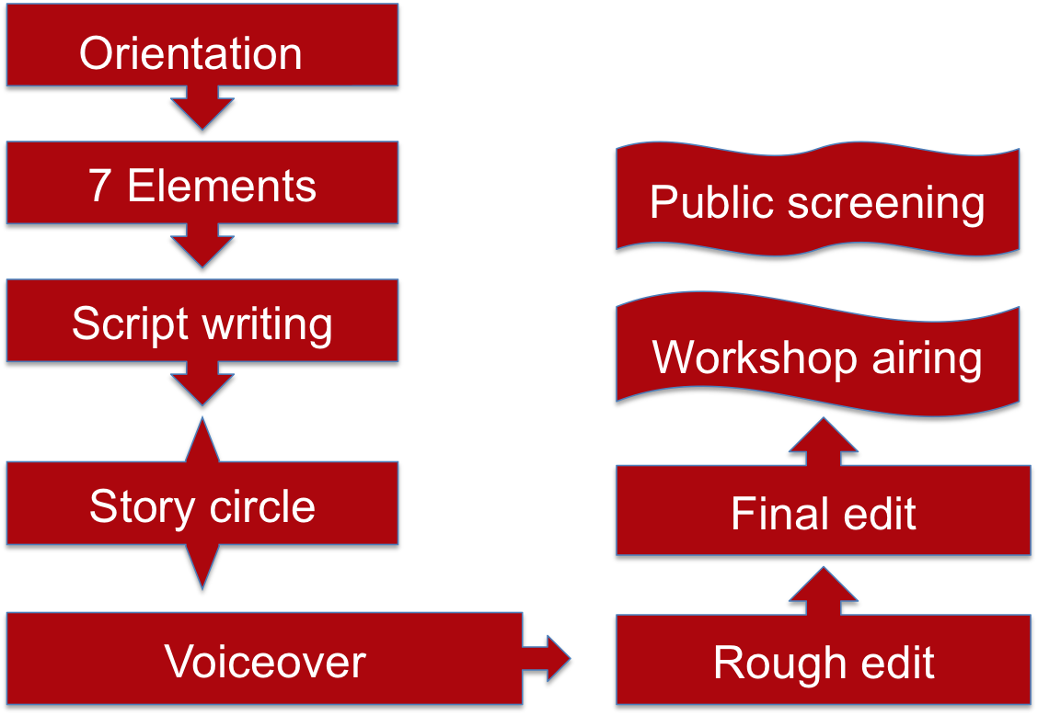
The Digital Storytelling Workshop Process

For this particular project the follow-up to the workshop was an essential piece of maintaining the integrity of the participants. Through continued dialogue about permissions for screening stories, participants were able to identify places and times in which they wanted their work showed or not showed.

Story Viewing Guidelines for Facilitators
The story screening process is one in which viewers and presenters alike may be surprised by the emotions and reactions elicited by the stories screened. In an effort to maximize time for viewing stories, discussing themes, and debriefing about the experience as a whole, there are a number of recommendations for how to set up the viewing space. Practical considerations for screenings include the screening area, technology, and a checklist of supplies. In addition, developing group guidelines as a means to facilitate a safe and respectful space is critical.

Screening Area
For the story screening itself, it is suggested the physical space where the screening will happen is set up ahead of time, and that it is different from the usual meeting space the group uses. For example if desks are usually in a row and students are seated behind each other, it is recommended that the room be set up in a semi-circle (facing the screen) that can be closed into a circle for discussions following the screening. Having the room set up ahead of time will mean that viewers can have the undivided attention of those facilitating the workshop as they arrive.

Technology
Since the quality of the digital stories is reliant on the media being used to screen them it is imperative that all technology is tested ahead of the screening date. Stories may need to be reformatted (saved in programs such as QuickTime), downloaded from websites and if being shown off of computers the computers themselves may need software updates to properly show the stories. Speakers, projectors and adapters will also need to be included in set up. For the day of the workshop all technology should be fully updated, so that it can be set up as a part of the room set-up prior to participant arrival.

Check-list for Screening
☐ Plan for setting up the room
☐ Viewing screen
☐ Projector
☐ Adapter for projector
☐ Computer cords
☐ Computer
☐ Power strip
☐ Flipchart
☐ Markers
☐ Tape
☐ Paper
☐ Pencils
☐ Tissues
☐ Water
☐ Signs to indicate where bathrooms are
☐ Area resource list
☐ Do a test run to check technology- that can often be the biggest challenge!

Developing Group Guidelines
As a way to create accountability and parameters within the group during the screening, the following group guidelines are suggested. In leading this activity (a great way to open the workshop after briefly detailing what digital stories are) it is suggested that there be a balance between participant brainstorming and facilitator suggestions. Having participants volunteer to take notes on a flipchart is a great way to engage the group. Following the creation of the list, hang it in a visible place in the room.

- Safe Space*: Establish the workshop as a safe place for participants to express their feelings and ask questions without judgment or persecution

- One Diva/One Mic: One person talks at a time; while they are sharing all others listen.

- Assume Good Intent: Be kind to each other. If someone is processing a new idea, assume that it is with integrity. Even if you disagree with someone, do so in a way that still values them as a group member.

- Step Forward/Step Back: If you talk a lot, challenge yourself to step back and allow those who are less vocal to speak up. If you are usually quiet, challenge yourself to step forward and participate more.

- Vegas Rule: What is said in this room stays in this room; including sharing that might occur through online platforms.*

- Active Listening: Show that you are engaged and care about what others are saying by looking at them as they talk, and avoiding interrupting them.

- “I” statements: In an effort to avoid generalizing or stereotyping, use “I” statements to express your particular views, experiences and opinions. (Discuss this briefly as a group, and explain the importance of taking ownership of your own emotions, versus blaming others).

- Self-Care: Take care of yourself, these stories can be triggering, complicated and upsetting. If you need to step out for water a quick walk or a phone-call, please do so. Prioritize your comfort and safety.

- Technology: Please be aware of your own use of technology during the screening. If you are able to please turn off/silence your phone and close your laptop.

* Please be sure to share with your group your agencies specifications around mandated reported/the report of abuse. The exception to the “Vegas” rule is in the event that someone reports something that indicated their immediate danger.

Mandated reporting protocol is detailed in the ethics sectios. Be sure to familiarize yourself with the mandated reporting rules with the group you are showing stories to. A good time to remind the group about this is during the group guideline introduction by explaining your role, and what you would need to report if shared.

Ensuring Emotional Support
As mentioned before, digital stories can be emotionally triggering. They are personalized narratives that work through the lived experience, memories, cultural identities, political world and questions of the storyteller. Though short, they are intense and the stories shared are distilled from a broader narrative that was honed throughout the story crafting process. In addition to having the room set-up ahead of time (furniture and technology) added measures that can be made to make viewers more comfortable include; having tissues and water readily available, having bathrooms clearly marked, having added resources available for processing intense emotions. This could mean having a school guidance counselors or social worker on hand, handing out area resources for support and letting participants know that they can step out of the screening at any point to regroup.

Viewing the Stories
This section of the guide provides tools for facilitators to use in leading discussions about the stories. We have created a set of general discussion questions that can be applied to all of the digital stories. Especially with stories that are intense, it can be difficult to begin to discuss the content and issues portrayed; having general guidelines to follow a group screening can be highly valuable. For each story, we have included a short summary, a complete transcript, a list of key issues addressed, and a set of specific questions that aim to bring out details and encourage a more thoughtful discussion around what viewers see and hear.

If a story screening follows a workshop, then it is appropriate to show all stories (if permission is giving by the storyteller). If stories are being shown as a means to spark discussion around a topic (in this case positive sexual health), we suggest showing a collection of 4-6 stories, to allow ample time for discussion. If there are similar themes, we also suggest grouping stories according to those themes, as a form of unspoken narration. In our experience, we have found that delaying discussion until after the collection of stories is shown is preferable. This way, the audience is more likely to see common or prominent themes that can spark rich discussion following the screening. Viewing the stories as a collection also gives the audience a chance to digest the story content prior to discussions. It is helpful to suggest that viewers have paper and pen available so they can write brief notes about each story during the screening.

Viewing Stories and Discussion Prompts

Pre-screening discussion prompts
This can be done as a call and response set up, by going around in a circle or by doing a brainstorm onto paper.

- What are you assumptions prior to seeing these?
- What has media taught you about young parents and how they begin their pathway to parenthood?

Post-screening discussion prompts

- How do you feel after watching the stories? Describe the parts of the stories (audio and visual) that especially moved you, and talk about why.
- What are your thoughts after watching the story? What did you learn from watching the story, about:
  - The people in it
  - The story’s setting
  - The issues raised by the story
  - Your own life
- How does the story talk either directly or indirectly about family making? Violence? Housing insecurities and surveillance?
- If you are a parent, what similarities do you see between your own experiences?
- What are some of the issues or conflicts that are in the story?
- How can these issues be tackled by:
  - You
  - Other individuals
  - Community groups
  - Health, education, or development organizations
  - Government agencies (local, regional, and/or national)
- How do things like lived experience, societal norms, and history influence how we talk (or don’t talk) about or teach sexual health?
- How do these stories influence how you will (or will not) talk to your children about sexual health?

http://storycenter.org/

