Create new speedtypes –

Step | Action
 | Navigate to Cost Code Hierarchy (Contract Setup, Cost Code Hierarchy)
Highlight ST-Speed Type Base (UMASS Cost Code
- Click New
- Click Organization Cost Code

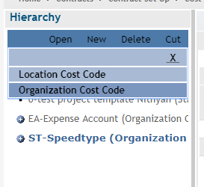

General section
- Enter Date – recommend 7/1/ of fiscal year created to be in synch with PS
- Name – this name appears in searches for the speedtype in the system
Detail section
- Separator – use the second “-“ in the drop down
- Cost Center – is speedtype number
- Cost type = Speed Type –
  - you will need to click the drop down and re-select speedtype tomake the chartfields appear
- Billable – check this if a billable speedtype
- Enter the Fund, Department Program, Class and Project, if applicable.
- If a Project, PC Business Unit is always UMAMH and Activity is always UM01

 | 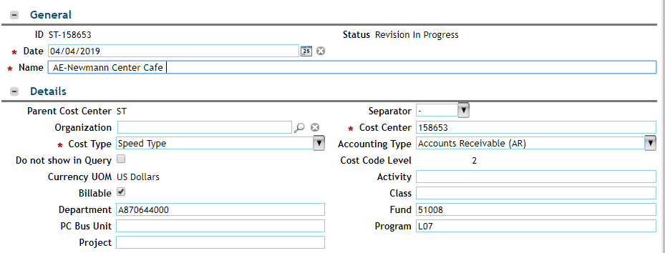
 | Click 
 | Click
 | End of Procedure.

