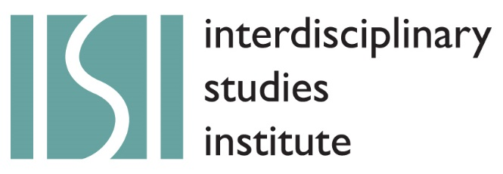

Graduate Seminar 2018: Call for Applications

Dissent

The question of dissent has gained great prominence. What will assent and dissent mean in this period, and how will they be exercised? The dynamic of the last presidential election was itself propelled by dissent against standard narratives on the part of specific sectors of the public. How then will dissent be conceived and organized going forward, whether this relates to the Black Lives Matter movement, women’s rights, gay and transgender rights, migrant and immigrant rights, human rights, labor rights, education, health and other areas of stress and vulnerability? In an era in which Islamophobia, racism, and xenophobia are renascent, questions of solidarity and dissent are likely to take on increasing importance. Where scientific consensus—for example on climate change—is under threat, there may for once be a paradoxical overlap between consensus and dissent. Where ‘truth’ itself has become a malleable political commodity, a matter of performance and simulacrum rather than fact, how will we tie dissent to notions of evidence and truth? How will evidence and truth be legitimated?

The political looms large in this call for applications, therefore. Quite possibly there will be moments of anticipation or inspiration from previous eras, whether the period of the Vietnam War, the civil rights struggle, or struggles for gender and sexual equality. At the same time, we might benefit from comparative approaches. How has dissent been organized and theorized in other times and places, or within specific cultures? Are there test cases we can study, whether in China, Russia, the former Soviet bloc, South Africa, Cuba or the Arab Spring? What are the options for national or transnational links? How is dissent in the personal sphere tied to the collective? Not despite but because of the serious issues, does comedy—and its history—offer a platform for dissent?

As always, we wish to stress the disciplinary and interdisciplinary dimensions of our topic. At times dissent will arise specifically because of disciplinary engagement, or the invention of a new discipline: there is Galileo’s reputed ‘And yet it moves.’ At times dissent will arise within disciplines when orthodoxy faces challenge; at times what was dissent will become the new orthodoxy. Will interdisciplinary approaches shake up the disciplines themselves? What then are the implications of our work for dissent and assent? How have artists broken with tradition? How have scientists done so? How has their work affected the public sphere? How will journalists see their role in this day and age? What are our philosophies of dissent? When it comes to dissent, we can think all the way from issues of education and public health to the activism and conformities of social media. Dissent may come into the very way we formulate our questions about dissent.

Guided by this particular political moment, therefore, the ISI encourages you to think widely around the topic, in ways that may help illuminate some of our present predicaments. We invite you to join a cohort of like-minded—or dissenting—colleagues as we construct a sustained conversation on dissent as our theme for this year.

The Interdisciplinary Studies Institute adds for the first time a forum for graduate students to participate in discussion and engagement across the disciplines. No matter your field, period, cultural focus, discipline or perspective, we invite graduate students from the humanities and arts and the social and natural sciences to submit a proposal setting out your contribution to the seminar's theme.

The proposal should describe in no more than 300 words the nature of your project and how you would present it to the seminar. The proposal should be accompanied a brief description of how your project contributes to your progress toward your degree in your graduate program, a brief endorsement by your principal faculty advisor, and a copy of your curriculum vitae. The 8-10 fellows who are selected will meet at regular intervals during the Spring 2018 semester. Each fellow presents once; during their presentation they facilitate discussion of their project, and they receive feedback reflecting the variety of interdisciplinary perspectives represented by the seminar participants. The obligations of the group include participating in a capstone event at the end of the year, attended by the participants' faculty advisors. Meetings will be held on 12-2 pm on Wednesdays or Thursdays (the day will decided based on participants' availability), so you must be free at one of those time. Proposals should be sent by email to isi@umass.edu by December 7, 2017.

For more information on the seminar or ISI, please contact the Director, John Kingston, at jkingston@linguist.umass.edu or see our website at www.umass.edu/isi. Major funding for ISI comes from the Provost, and the Deans of the College of Humanities and Fine Arts and the College of Social and Behavioral Sciences.

ISI: Director, Board Members, and Graduate Research Assistants
John Kingston, ISI Director, Department of Linguistics
Lisa Henderson, Department of Communication
Randall Knoper, Department of English
Kathleen Lugosch, Department of Architecture
Lauren Silber, Department of English
Wouter van Erve, Department of Political Science

