Punch Edits
Occasionally, as a manager, you will need to edit an employee’s punch because it is incorrect or because an employee forgot to punch. There are various reasons why and by editing a punch, you are confirming that the change is correct. You will still have to approve the employee’s time before payroll is run and sent to HR Direct

If you are not sure if a particular edit is appropriate or allowed, please contact the your HR Office before making any changes.

- Navigate to the employee’s time card and click on the punch you need to add or edit
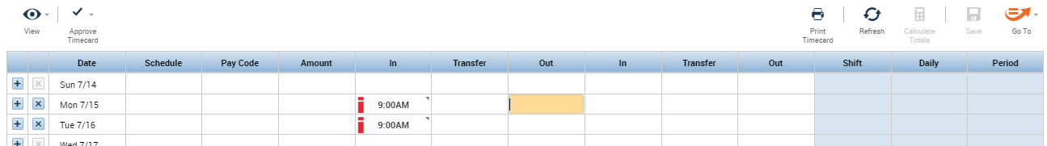

- Enter or overwrite the existing value with the new punch time
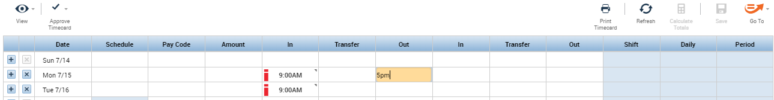

- Best practice is to add a comment as to why you are changing a punch, especially if it is an unusual situation. To add a comment, remain in the punch field you just updated and right click. Select Comments at the bottom
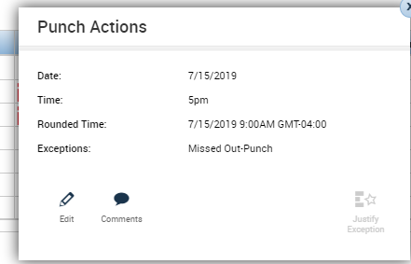

- Select a Comment type and add an additional note if necessary and click Add and then OK
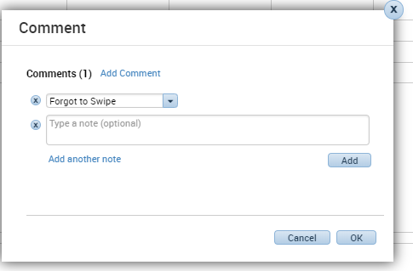

- Anyplace there is a comment you will see a comment bubble in the right corner

- Click Save in the upper right of the page to save the edits.
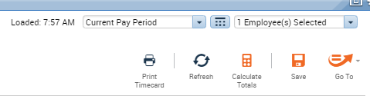

- All actions on a timecard are tracking in the Audits at the bottom of the page
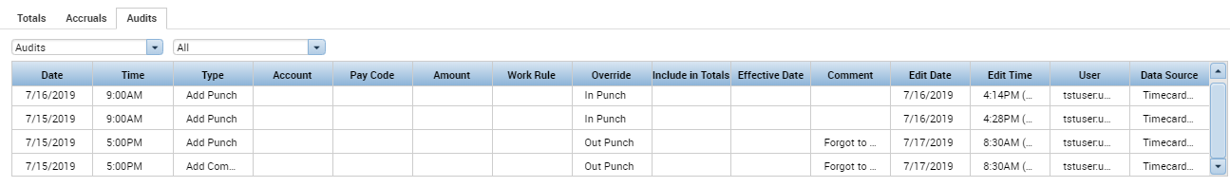

- End

